Ideation Phase
Brainstorm & Idea Prioritization Template

Date | 16-10-2026
Team ID | HP-MERN-2026
Project Name | HotelPro — Human-Centered Hotel Management System
Maximum Marks | 4 Marks

Brainstorm & Idea Prioritization Template:
Brainstorming provides a free and open environment that encourages everyone within a team to participate in the creative thinking process that leads to problem solving. Prioritizing volume over value, out-of-the-box ideas are welcome and built upon, and all participants are encouraged to collaborate, helping each other develop a rich amount of creative solutions.
Use this template in your own brainstorming sessions so your team can unleash their imagination and start shaping concepts even if you're not sitting in the same room.
Reference: https://www.mural.co/templates/brainstorm-and-idea-prioritization
Step-1: Team Gathering, Collaboration and Select the Problem Statement

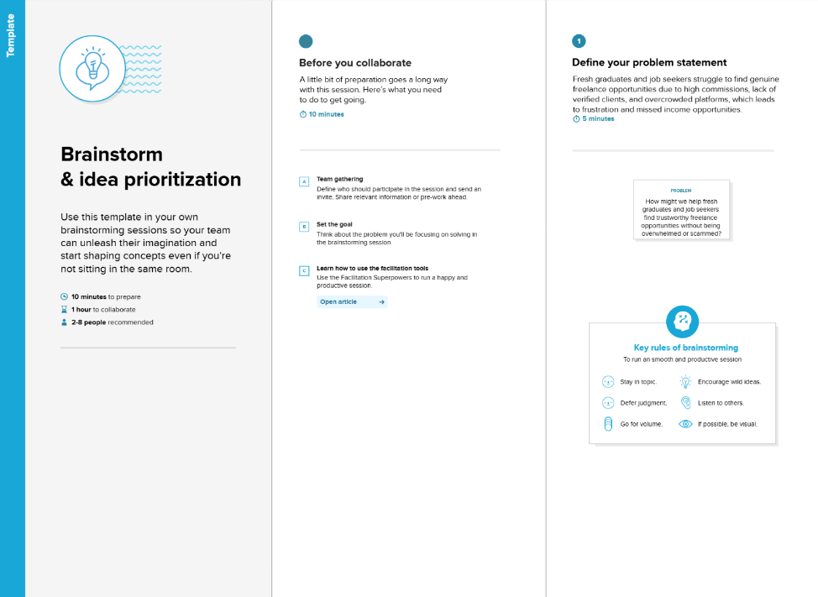

Step-2: Brainstorm, Idea Listing and Grouping
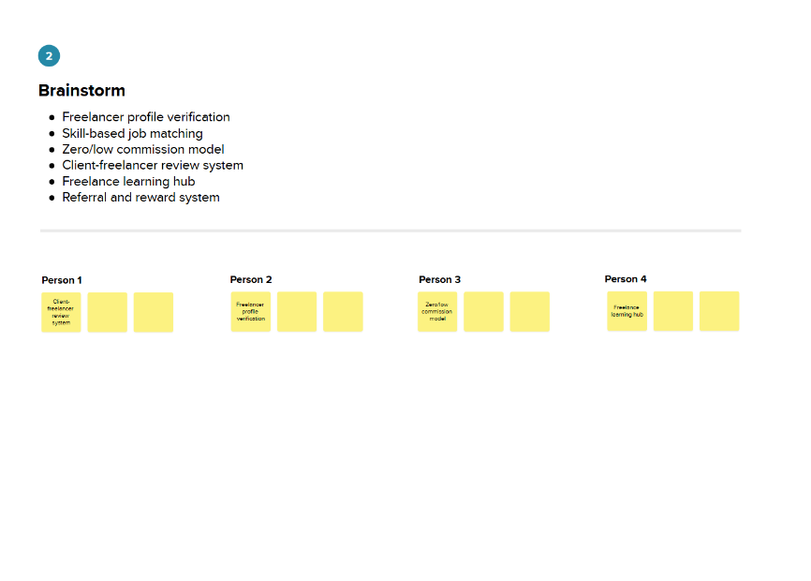
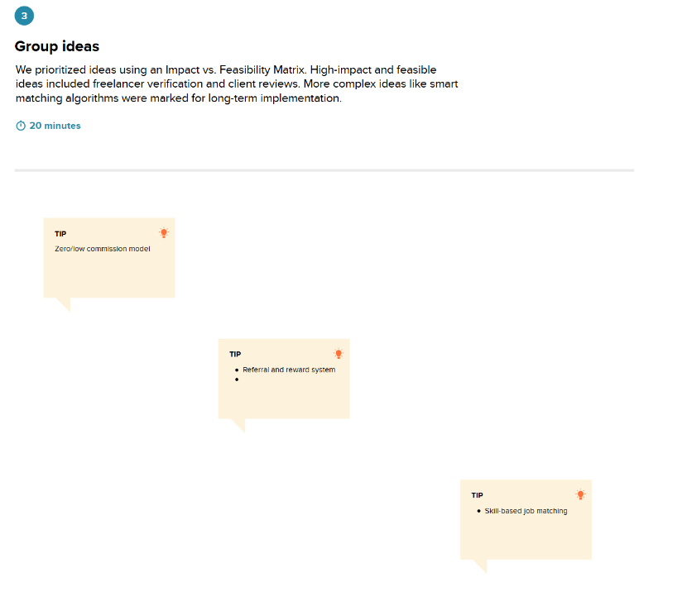

Step-3: Idea Prioritization
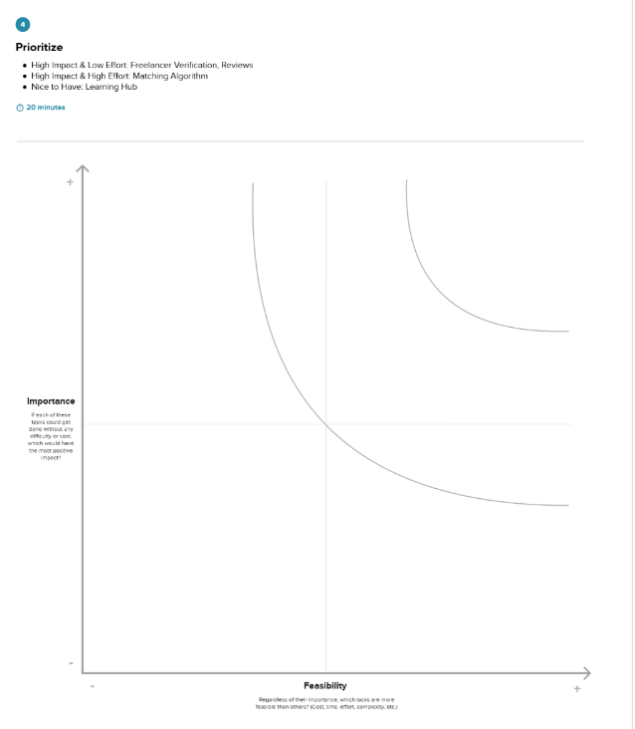

HotelPro Brainstorming & Idea Prioritization Breakdown:
Step-1: Problem Statement Selection & Brainstorming Goals
● Core Problem Selected: How can we build an editorial, human-centered hotel platform that eliminates online payment failure anxiety, safeguards guest stay invoices, and unifies front-desk and housekeeping operations on local MERN stack architecture?
● Team Participants: Full Stack MERN Developer & UI/UX Designer (Divyansh Agarwal).
● Brainstorming Rules: Prioritize human empathy over complexity; guarantee offline resilience; strictly adhere to WCAG 2.1 AA accessibility standards.
Step-2: Idea Generation & Affinity Grouping
● Cluster A (Human-Centered UI/UX): Editorial botanical palette (#234B3B forest green, #B88B5A brass gold), Playfair Display headings, tactile micro-interactions, 1-click demo credential switcher for instant evaluation.
● Cluster B (Payment Resilience & Sandbox): 100% offline simulated payment sandbox across 4 payment methods (Card, UPI QR, Net Banking, Pay at Property); zero network error guarantee; local storage caching with MongoDB sync.
● Cluster C (Privacy & Security): Direct URL route restriction for confirmation vouchers; authenticated in-page receipt modal dialog; print stylesheet removing public navigation/footers.
● Cluster D (Front Desk & Operations): Unified front-desk check-in console; instant room key assignment; housekeeping grid with live room sanitation status toggling.
● Cluster E (Executive Intelligence): Dynamic Recharts occupancy graphs; RevPAR metric cards; real-time operational toast alert popup; immutable administrative audit log trail.
Step-3 & 4: Impact vs. Feasibility Prioritization Matrix
● QUADRANT 1: High Impact & High Feasibility (Immediate Core Implementation): 100% offline simulated payment sandbox with zero network errors; Direct URL access block & authenticated in-page receipt modal; Real-time multi-attribute search and destination quick-filter chips; Role-based route guard architecture (Guest, Staff, Manager, Admin); Front Desk check-in/out and Housekeeping room status synchronization.
● QUADRANT 2: High Impact & Moderate Feasibility (Pillar Features): Interactive Recharts analytics dashboard with RevPAR and occupancy trends; Localhost IPv4 loopback MongoDB optimization (127.0.0.1) for zero latency; Clean voucher print stylesheets and accessible modal focus traps.
● QUADRANT 3: Low Impact & High Feasibility (Nice-to-Have Polish): Non-intrusive live operational alert toast popup at bottom-right; Editorial SVG icon badges and tactile button press animations; Interactive Style Guide showcase at /style-guide.
● QUADRANT 4: Low Impact & Low Feasibility (Deferred to Roadmap): Native mobile application builds (React Native / iOS / Android); Multi-currency live forex currency exchange ticker; IoT physical RFID keycard encoder hardware integration.

